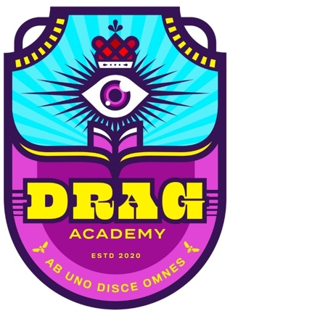
ART CREATION AWARD BUDGET
Maximum Budget: $1,500.00

Budget Category | Amount | Budget Note
Artist Fees
Materials & Supplies
Studio Rental
Equipment Rental
Travel
Total

Eligible Expenses
- The time and materials needed to create new work for the project(s) described in your application. Eligible expenses include:
  - material and supplies, production costs
  - studio space or equipment rental
  - artist fees – payment to yourself or other artists engaged in creating the work.
  - travel, only if it is required to create the work (example: photographer’s travel to the location of the subject of their work)

Ineligible Expenses
- major capital expenditures, including buying, leasing or renovating buildings and purchase of major equipment
- marketing activities (websites, brochures)
- professional development or training activities
- travel costs not related to the project
- fundraising projects
- living or personal expenses, such as subsistence

